SENIOR SIX TERM 2 GEGRAPHY LESSON NOTES 2026
TOPIC 1/3: Slope Development
Competency: The learner analyses spatial and temporal variations of slope processes by examining their nature, factors influencing their occurrence and impact to devise strategies for managing slope-related hazards.
A slope refers to the rise or fall of the land surface, essentially describing how steep or gentle the terrain is.
Evolution of a slope
The evolution of a slope in geography refers to how the shape and steepness of land surfaces change over time due to processes like weathering, erosion, and mass movement.
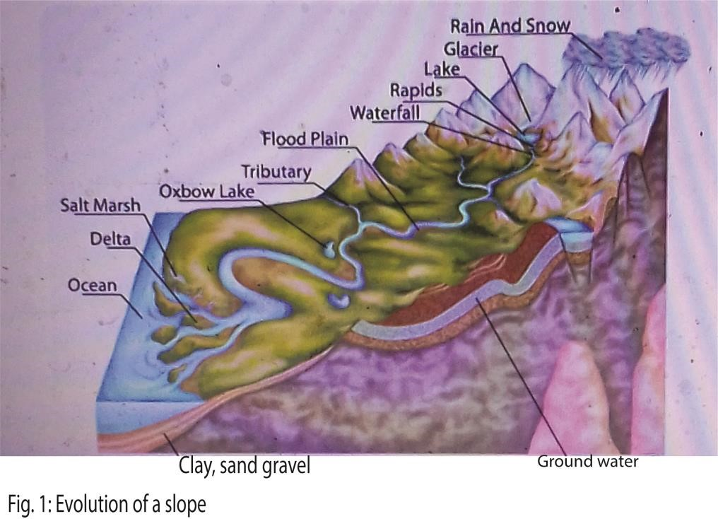
Figure 1 provides a channel overview of land scape evolution from steep mountain to flat plain near the ocean. It shows how land changes from high steep relief with water falls and rapids near the top representing an early stage of the river. The middle section the slope become gentler with meanders and flood plain developing in mature stage. Finally, at the bottom near the ocean, the land is nearly flat forming peneplain in the old stage.

Factors Driving Slope Evolution
- Weathering: Breaks down rock, producing regolith.
- Erosion: Removes weathered materials material via water, wind, or ice.
- Mass movement: Landslides, soil creep, and rockfalls reshape slopes.
- Climate: Rainfall, temperature, and vegetation cover influence slope stability.
- Human activity: Farming, construction, and deforestation accelerate slope changes.

The theories of slope development
These are proposed explanation or models used to how slopes change over time due to erosion, weathering, and tectonic forces.
- Slope Decline Theory (W.M. Davis)
Proposed by William Morris Davis in 1899, this theory is linked to his "Cycle of Erosion".
  - Main Idea: Slopes gradually lose height and steepness over time, a process called downwearing.
  - Evolution: Slopes pass through youthful (steep), mature (moderate), and old (very gentle) stages.
  - Result: Upper parts weather faster than they can be removed, leading to an eventual flattening into a featureless plain called a peneplain.
- Slope Replacement Theory (Walther Penck)
Walther Penck proposed this as a dynamic alternative to Davis, focusing on the relationship between tectonic uplift and erosion.
  - Main Idea: A steeper slope is replaced from below by gentler slopes as denudation occurs.
  - Slope Forms: Slope shape reflects the rate of uplift: convex (increasing uplift), straight (constant uplift), and concave (decreasing uplift).
  - Result: The cycle ends in a low-relief surface called an endrumpf.
- Parallel Retreat Theory (L.C. King)
Lester Charles King developed this theory based on observations of arid and semi-arid landscapes, such as the African savanna.
  - Main Idea: Slopes retreat backward while maintaining their original gradient and angle.
  - Slope Elements: King identified four essential parts: waxing slope (top convexity), free face (bare rock cliff), debris slope (talus), and waning slope (basal concavity/pediment).
  - Result: The merging of expanding pediments creates a broad, gently sloping surface called a pediplain.
- Wood’s Theory of Slope Evolution (Alan Wood, 1942)
Wood proposed a composite model that combined elements of retreat and decline.
  - Process: He suggested that a cliff (free face) retreats parallel to itself while weathered material (scree) accumulates at the base, protecting it and gradually burying it.
  - Standard Profile: A fully developed slope consists of four elements similar to King's model.
  - Flexibility: He argued that climate and local rock structure determine whether a slope will primarily retreat or decline.
- Statistical Equilibrium Theory (A.N. Strahler)
Strahler applied statistical methods to measure slope angles in different regions.
  - Main Idea: Slopes maintain an equilibrium angle proportional to the channel gradient of the local drainage system.
  - Function: This angle adjusts to allow for the steady and efficient removal of debris under prevailing climate and soil conditions.
Applicability of various slope development theories in different environments (e.g., humid vs. arid) and their limitations
Slope development theories (Davis, Penck, King, Strahler, etc.) were designed to explain how slopes evolve, but their applicability varies depending on environmental conditions like climate, geology, and human activity. Each theory has strengths and limitations.
Applicability in Different Environments
- Humid Environments (e.g., tropical or temperate regions) o Davis’ Slope Decline Model: Works best here because heavy rainfall and chemical weathering gradually reduce slope steepness, leading to gentler landscapes.
  - Limitations: Oversimplifies; assumes uniform erosion and ignores tectonic activity.
- Arid Environments (e.g., deserts, semi-arid regions) o King’s Parallel Retreat Model: More applicable, as resistant rock escarpments retreat backward while maintaining steepness due to mechanical weathering and sparse vegetation.
  - Limitations: Doesn’t account for variations in rock resistance or episodic flash floods.
- Regions with Active Tectonics (mountainous zones) o Penck’s Slope Replacement Model: Useful because it considers uplift and erosion simultaneously, explaining why slopes can remain steep while retreating.
  - Limitations: Assumes continuous uplift and uniform erosion, which rarely occurs.
- Complex Environments (mixed climates, varied geology) o Strahler’s Complex Model: Most realistic, as it integrates multiple processes (weathering, erosion, tectonics, vegetation, human activity). o Limitations: Too broad; lacks predictive precision compared to simpler models.
Summary Table
Theory | Best Environment | Applicability | Limitations
Davis’ slope decline | Humid regions | Explains gentle slope evolution | Ignores tectonics, oversimplifies
Penck’s slope replacement | Tectonically active areas | Considers uplift + erosion | Assumes uniform processes
King’s parallel retreat | Arid regions | Explains scarp retreat | Neglects climatic variability
Strahler’s complex model | Mixed/varied environments | Accounts for multiple factors | Too general, less predictive
Key Takeaway
  - Humid climates → Davis’ model fits better (gentle slope decline).
  - Arid climates → King’s model explains parallel retreat of scarps.
  - Tectonic regions → Penck’s model highlights uplift-erosion balance.
  - Mixed/complex settings → Strahler’s model is most realistic but less precise.

Types of Mass Wasting
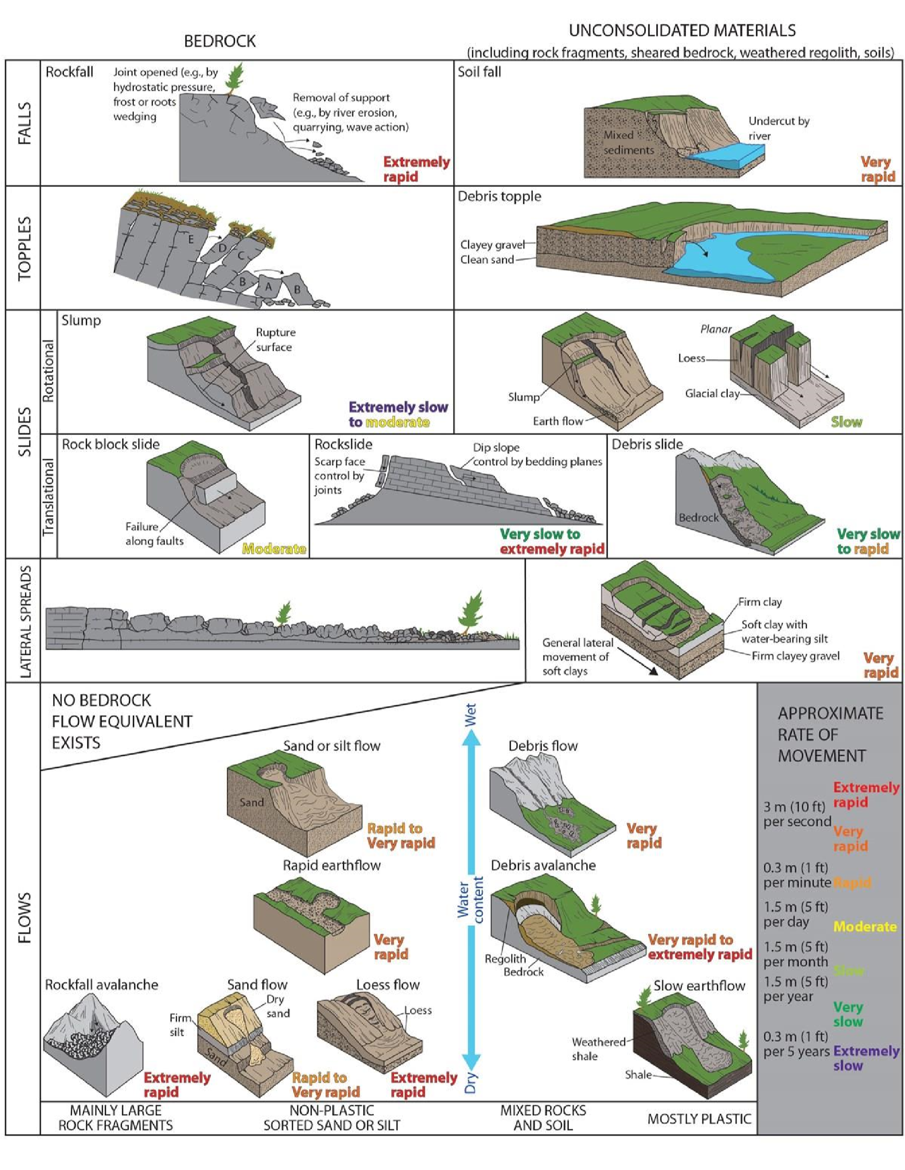
Mass wasting is the downslope movement of soil, rock, and debris under the direct influence of gravity. It differs from erosion because the material is not carried by water, wind, or ice—it simply moves downslope due to gravity, often triggered by factors like water saturation, earthquakes, or human activity.
- Creep: Very slow, gradual downslope movement of soil and regolith, often caused by freeze-thaw or wet-dry cycles.
- Slump: Rotational movement of material along a curved surface, leaving a crescentshaped scar.
- Rockfall: Sudden detachment of rock fragments from steep slopes or cliffs.
- Debris flow: Rapid downslope movement of water-saturated soil, rock, and organic matter, common in mountainous regions.
- Earthflow: Viscous flow of fine-grained, water-saturated material, slower than debris flows.
- Mudflow: Fast-moving slurry of mud and water, often occurring in arid or semi-arid regions after heavy rain.
- Avalanche: Rapid flow of snow, ice, and debris downslope.
- Solifluction: Slow downslope flow of water-saturated soil in periglacial environments.
Summary Table
Type | Speed | Material | Trigger
Creep | Very slow | Soil/regolith | Freeze-thaw, wet-dry cycles
Slump | Moderate | Soil/rock | Water saturation, gravity
Rockfall | Fast | Rock fragments | Weathering, earthquakes
Debris flow | Very fast | Soil, rock, water | Heavy rainfall
Earthflow | Moderate | Fine-grained soil | Water saturation
Mudflow | Fast | Mud + water | Intense rainfall
Avalanche | Very fast | Snow, ice, debris | Gravity, melting, earthquakes
Solifluction | Slow | Saturated soil | Periglacial thawing
Key Takeaway
Mass wasting processes range from slow soil creep to catastrophic landslides and debris flows, shaped by gravity, water, and environmental triggers. Understanding these processes is vital for hazard management, especially in mountainous and unstable regions.

Processes Driving Mass Wasting
- Gravity: The fundamental force pulling material downslope.
- Water saturation: Adds weight and reduces cohesion, making slopes unstable.
- Weathering: Weakens rock and soil, preparing material for movement.
- Earthquakes: Shake slopes, triggering landslides and rockfalls.
- Human activity: Deforestation, mining, and construction destabilize slopes.
- Freeze-thaw cycles: Expand cracks in rocks, loosening material for movement.

Impact of mass wasting on environment
- Landscape modification: It creates new landforms such as scarps, hummocky terrain, and depositional fans. And Alters slope profiles, valleys, and river courses.
- Soil erosion and loss of fertile land: Removes topsoil, reducing agricultural productivity. And Leads to desertification in extreme cases.
- Deforestation and vegetation loss: Uproots trees and plants, destroying habitats, thereby reducing biodiversity and disrupts ecosystems.
- Water systems disruption: Landslides can block rivers, forming temporary lakes.
Sediment loads increase in rivers, affecting aquatic life and water quality.
- Hazards to human settlements: Damages infrastructure such as roads, bridges, and buildings. It causes displacement of communities and economic losses.
- Climate and microclimate effects: Exposed bare soil increases surface runoff and reduces infiltration. It also changes local hydrology and slope stability.
Impact of mass wasting on human activities
- Damage to infrastructure: Roads, bridges, railways, and pipelines can be destroyed or blocked by landslides which Increases maintenance costs for transportation networks in mountainous regions.
- Loss of property and settlements: Houses and entire villages may be buried or displaced. Relocation of communities becomes necessary in high-risk zones.
- Agricultural disruption: Loss of fertile topsoil reduces crop yields. Terraced farming areas can collapse, leading to food insecurity.
- Economic consequences: High costs of reconstruction and disaster relief. Tourism in mountainous areas may decline after major landslides.
- Human casualties and displacement: Landslides and mudflows often cause fatalities.
While survivors may face long-term displacement and psychological trauma.
- Water supply and hydropower impacts: Landslides can block rivers, forming temporary lakes that later burst, causing floods. Sediment loads reduce dam efficiency and water quality.
- Transportation delays and isolation: Mountainous communities may be cut off for weeks after slope failures. Emergency response becomes difficult in remote areas.

Case studies of deadly mass wasting events in history
The Oso landslide (USA, 2014) and the Sierra Leone mudslides (2017) are two of the deadliest mass wasting events in recent history. Both highlight how natural factors (rainfall, geology) and human activity (deforestation, settlement patterns) combine to create disasters. Their responses reveal strengths and weaknesses in disaster management.
Case Study 1: Oso Landslide, Washington, USA (2014) Causes
- Heavy rainfall led to soil saturation and slope instability. o The hill had a history of smaller landslides, showing long-term geological vulnerability. o Weak glacial sediments amplified slope collapse. Effects
- 43 people killed, 49 homes destroyed, $60 million in property damage. o A rural neighborhood was buried under debris covering 1 square mile. o Highway 530 was blocked, isolating communities. Response Measures
- Immediate search and rescue by local, state, and federal agencies.
- Federal disaster declaration enabled funding and support. o Long-term hazard mapping and stricter land-use planning introduced. Critical Evaluation
- Rescue efforts were rapid but hampered by the scale and mobility of debris. o Hazard warnings existed but were underestimated; residents were not fully informed of risks.
- Post-disaster reforms improved monitoring, but prevention was reactive rather than proactive.

Case Study 2: Sierra Leone Mudslides, Freetown (2017) Causes
- Three days of torrential rainfall triggered slope failure.
- Deforestation and unregulated urban expansion on steep hillsides worsened vulnerability. o Soil erosion and poor drainage systems contributed.
Effects
- Over 1,100 people killed, 3,000 displaced. o Hundreds of buildings destroyed, leaving thousands homeless. o Severe contamination of water sources and spread of disease. Response Measures
- Emergency rescue and recovery coordinated by Sierra Leone government, UN agencies, and NGOs.
- UNICEF used digital platforms (U-Report) to engage affected communities. o International aid provided relief supplies, medical care, and temporary shelters. Critical Evaluation
- Response was swift but limited by poor infrastructure and lack of preparedness.
- Community engagement via digital tools was innovative but reached only part of the population.
- Long-term measures (reforestation, urban planning reforms) remain weak, leaving recurrence risks high.
Comparative Analysis
Event | Causes | Effects | Response | Effectiveness
Oso,  USA  (2014) | Heavy rainfall, weak glacial sediments, history of slides | 43 deaths, $60M damage, homes destroyed | Federal aid, hazard mapping, stricter planning | Effective long-term reforms, but risk underestimated
Sierra  Leone  (2017) | Torrential rain, deforestation, poor urban planning | 1,100+ deaths, 3,000 displaced,  water contamination | Govt + UN rescue, UNICEF digital engagement, aid | Swift but limited; long-term prevention weak
Key Takeaway
  - Oso landslide shows the importance of scientific hazard mapping and proactive land-use planning.
  - Sierra Leone mudslides highlight how deforestation and poor urban governance amplify natural hazards.
  - Both cases reveal that while emergency responses save lives, long-term prevention and community awareness are critical to reducing future risks.

Warning signs to mass wasting accidents
- Steep slopes: Slopes with high angles are more vulnerable because gravity exerts stronger downslope force.
- Weak or unconsolidated materials: Loose soils, weathered rock, or volcanic ash are easily mobilized.
- Water saturation: Areas with heavy rainfall, poor drainage, or high groundwater levels are prone to slope failure.
- Sparse vegetation: Lack of plant roots reduces soil cohesion, common in deforested or arid regions.
- Evidence of past landslides: Scarps, hummocky terrain, or displaced blocks indicate previous slope failures.
- Seismic activity: Earthquake-prone regions often experience landslides due to ground shaking.
- Human activity: Road cuts, mining, terracing, and construction destabilize slopes.
- Displaced Infrastructure: Tilted utility poles, sagging lines, cracked road pavements, or sticking doors and windows in nearby buildings are early warning signs of ground movement.
- Drainage Patterns: Landscapes with high drainage density or locations near first- and second-order streams are prone to undercutting, which removes support from the base of the slope.
- Using Modern Detection Technologies (2025) such as remote sensing and Satellite Radar.

Measures to Control Mass Wasting
Mass wasting cannot be completely prevented because it is a natural geomorphic process, but its impacts can be minimized through engineering, environmental management, and planning. The goal is to stabilize slopes, reduce triggers, and protect human activities.
Engineering Measures
- Retaining walls: Built at slope bases to hold back soil and rock.
- Terracing: Converts steep slopes into stepped levels to reduce runoff and erosion.
- Drainage control: Channels, culverts, and pipes remove excess water that weakens slopes.
- Rock bolts and netting: Secure loose rock fragments on cliffs to prevent rockfalls. • Slope grading: Reduces slope angle to lower gravitational stress.
Environmental & Biological Measures
- Afforestation: Planting trees and vegetation to bind soil with roots.
- Controlled grazing: Prevents overgrazing that exposes soil to erosion.

- Revegetation projects: Restores vegetation cover on disturbed slopes.
Planning & Policy Measures
- Hazard mapping: Identifies high-risk zones to restrict settlement and construction.
- Land-use regulations: Prevents building on unstable slopes.
- Early warning systems: Rainfall thresholds, sensors, and monitoring to alert communities.
- Community awareness: Education on slope risks and safe practices.

TOPIC 2/3: Problems of Food Supply
Competency: The learner analyses local and global food supply problems as well as strategies adopted to address them using relevant information and geographic tools, and proposes innovative solutions to ensure food security for all.

Trends in World Food Supply
In general, higher levels of economic development are strongly associated with more secure and diverse food supply, while low-income countries face persistent undernourishment and vulnerability to shocks. Statistics show that income growth changes diets, improves agricultural productivity, and reduces hunger, but also introduces challenges like obesity and food inflation.
Relationship Between Economic Development and Food Supply
- Low-income countries o Food supply is often unstable, heavily dependent on subsistence farming.
  - High rates of undernourishment: FAO estimates nearly 30% of people in SubSaharan Africa face food insecurity.
  - Limited infrastructure and technology reduce productivity.
- Middle-income countries o Rising incomes increase demand for diverse diets (meat, dairy, processed foods). o Food supply improves with investment in irrigation, mechanization, and imports.
  - Vulnerable to food inflation: IMF reports that between 2019–2021, global undernourishment rose by 126 million people, partly due to rising food prices.
- High-income countries o Stable food supply with advanced agricultural systems, imports, and storage.
  - Undernourishment rates are below 2%, but obesity and food waste are major issues.
  - Strong safety nets and subsidies protect consumers from shocks.
Comparative Statistics
Income Level | Undernourishment Rate | Food Supply Characteristics
Low-income | ~30% (Sub-Saharan Africa) | Subsistence farming, unstable supply
Middleincome | ~12–15% (South Asia, parts of Latin  America) | Growing diversity, vulnerable to inflation
High-income |  | Stable supply, obesity & waste issues

Food Shortages in Developing Countries
Food shortages remain one of the most pressing challenges in many developing nations. They are caused by a mix of environmental, economic, social, and political factors, and their impacts ripple across health, education, and economic growth.
Causes of Food Shortages
- Rapid population growth: Demand for food outpaces supply, especially in regions with high fertility rates.
- Climate change: Droughts, floods, and unpredictable rainfall reduce agricultural productivity.
- Poor agricultural infrastructure: Limited irrigation, storage, and transport systems lead to post-harvest losses.
- Economic constraints: Poverty reduces access to food; farmers lack capital for modern inputs.
- Political instability: Conflicts and weak governance disrupt farming and food distribution.
- Dependence on imports: Global price fluctuations make food unaffordable for lowincome households.
Impacts of Food Shortages
- Malnutrition: High rates of stunting, wasting, and micronutrient deficiencies among children.
- Health crises: Increased vulnerability to disease due to weakened immune systems.
- Economic stagnation: Reduced labor productivity and higher healthcare costs.
- Education disruption: Hungry children struggle to attend or perform in school.
- Social unrest: Food insecurity can trigger protests, migration, and instability.
Measures to Address Food Shortages
- Investment in agriculture: Improve irrigation, mechanization, and access to fertilizers.
- Climate-smart farming: Drought-resistant crops, agroforestry, and water conservation. (iii) Food aid and safety nets: Emergency relief, school feeding programs, and subsidies.
- Improved storage and transport: Reduce post-harvest losses and connect farmers to markets.
- Policy reforms: Land tenure security, fair trade policies, and investment in rural development.
- Education and empowerment: Training farmers, empowering women, and promoting nutrition awareness.
Key Takeaway
Food shortages in developing countries are not just about lack of food production—they are deeply tied to poverty, governance, climate, and infrastructure. Tackling them requires a multi-pronged approach: boosting agricultural productivity, building resilience to climate change, and ensuring equitable access to food.

Policies and programs aimed at increasing food supplies in Uganda
Uganda has adopted several policies and programs to strengthen food security and increase food supplies, focusing on agricultural modernization, nutrition, and multi-sector collaboration. These initiatives aim to reduce hunger, improve productivity, and build resilience against climate and economic shocks.
Key Policies and Programs
- Uganda Food and Nutrition Policy (2003) o Provides a framework for ensuring food and nutrition security. o Promotes sustainable agricultural practices, improved food storage, and better dietary diversity.
  - Encourages community participation in food production and nutrition awareness.
- National Planning Authority’s Hunger-Free Uganda Policy Paper (2023) o Advocates for a hunger-free society by integrating food security into national development plans.
  - Focuses on reducing malnutrition, strengthening agricultural value chains, and improving access to markets.
- Uganda Multi-Sectoral Food Security and Nutrition Project (UMFSNP) o Implemented by the Ministry of Agriculture, Animal Industry and Fisheries (MAAIF) with support from the Ministry of Health and Education.
  - Aims to improve household food security and nutrition through irrigation, improved seeds, and farmer training.
  - Includes school feeding programs and community-based nutrition education.
- National Agricultural Policy (2013) o Promotes commercialization of agriculture, mechanization, and climate-smart farming.
  - Encourages private sector investment in food production and agro-processing.
- Uganda National Action Plan on Nutrition (UNAP) o Coordinates multi-sector efforts to tackle malnutrition. o Links food supply policies with health and education interventions.

Proposed action plan to end food shortages in Africa
- Boost agricultural productivity o Provide farmers with improved seeds, fertilizers, pest control and affordable mechanization.
  - Expand irrigation and water harvesting to reduce reliance on rainfall.
- Strengthen climate resilience o Promote drought-resistant crops and climate-smart farming practices.
  - Restore degraded soils and invest in agroforestry.
- Reduce post-harvest losses o Build storage facilities, silos, and cold chains.
  - Train farmers in better handling and preservation techniques.
- Improve market access o Invest in rural roads and digital platforms to connect farmers to buyers.
  - Facilitate regional trade to stabilize food supply across borders.
- Expand social safety nets o School feeding programs, targeted food aid, and cash transfers for vulnerable households.
  - Emergency reserves for drought and conflict-affected areas.
- Empower communities o Support women and youth in agribusiness. o Provide training, extension services, and nutrition education.
  - Promote cooperatives
  - Provide financial incentives such agricultural credit at low interest rates
Key Takeaway
Ending food shortages in Africa requires a multi-pronged approach: raising productivity, building resilience to climate shocks, cutting losses, and ensuring equitable access through markets and safety nets.

TOPIC 3/3: Lake and Sea Coasts
Competency: The learner demonstrates appreciation of coasts as dynamic physical environments through examining their nature, geomorphic processes modifying them, and resultant features, as well as benefits and challenges of living in coastal areas to inform decisions aimed at developing such areas.
A coast is part of land bordering the sea or any other extensive tract of water like ocean. The nature of the coast is influenced by wave action, sea level changes and occurrence of coral rocks.

A wave is an oscillation or ripples on water caused by wind, earthquakes, volcanic activity like eruption and/or moving objects on water like ships, boats, fish, animals and so on.

Tides and marine Waves
Tides and marine waves are both rhythmic movements of ocean water, but they differ in origin, scale, and impact. Tides are driven by gravitational forces of the moon and sun, while waves are mainly generated by wind energy passing over the ocean surface.
Nature of Tides
Gravitational origin: Caused by the pull of the moon and sun on Earth’s oceans.
Periodic rise and fall: Occur in predictable cycles (usually two high and two low tides daily).
Large-scale movement: Involves entire ocean basins, not just surface water.
Ecological significance: Shapes coastal ecosystems, estuaries, and intertidal zones.
Human impact: Influences fishing, navigation, and tidal energy generation.

Nature of Marine Waves

Wind-driven energy: Most waves are formed by wind friction on the ocean surface.
Energy transfer: Waves transmit energy across water; the water itself moves in circular orbits.
Varied size and speed: Ranges from small ripples to massive storm waves.
Localized impact: Erodes coastlines, builds beaches, and shapes marine landforms.
Global reach: Waves can travel across entire ocean basins if unobstructed.
Comparison Table
Feature | Tides | Marine Waves
Cause | Gravitational pull of moon & sun | Wind energy, storms, seismic activity
Scale | Global, ocean-wide | Local to basin-wide
Frequency | Predictable cycles (daily) | Irregular, depends on wind/storms
Impact | Navigation, ecosystems, tidal energy | Coastal erosion, beach formation, surfing
Significance in Coastal Landscapes
- Tides: Create tidal flats, salt marshes, and estuaries; regulate nutrient cycles and biodiversity.
- Waves: Shape cliffs, beaches, spits, and bars; drive erosion and deposition processes.
- Together, they continuously remodel coastlines, influencing both natural ecosystems and human activities.
In summary: Tides are predictable, large-scale movements caused by celestial gravity, while marine waves are wind-driven energy transfers that shape coastlines locally and globally. Both are essential in understanding coastal dynamics and long-term landscape evolution.

Formation of Coastal Landforms
- Marine erosion: Waves erode cliffs through hydraulic action, abrasion, attrition, and solution, forming caves, arches, stacks, and stumps.
- Marine deposition: Sediment carried by waves and currents accumulates to form beaches, spits, bars, and dunes.
- Tidal and current action: Tides and longshore drift redistribute sediments along coasts, shaping depositional features.
- Biological and chemical processes: Coral reefs and mangroves develop through biological activity, stabilizing coasts.
- Human influence: Coastal engineering (sea walls, groynes) alters natural processes, creating artificial landforms.

Constructive and destructive waves
Coastal waves are broadly classified into two types: constructive and destructive. They differ in energy, frequency, and the way they shape coastlines through erosion or deposition.
Constructive Waves
Formation: Generated in calm weather with long fetch and low wind speeds.

Characteristics:
- Low height and long wavelength.
- Strong swash (water moving up the beach) and weak backwash (water returning to the sea). o Occur less frequently (6–8 waves per minute).

Impact:
- Deposit materials like sand and shingle i.e. the waves carry out more deposition than erosion.
- Build up beaches, forming berms and ridges. o Create gentle, sloping coastlines.
Destructive Waves
Formation: Produced in stormy conditions with strong winds and short fetch.

Characteristics:
o High height and short wavelength. o Strong backwash that removes material from the beach. o Occur more frequently (10–14 waves per minute).

Impact:
o Erode coastlines, forming cliffs, wave-cut platforms, and removing beach sediment. o Create steep, narrow beaches. o Increase coastal hazards like flooding and erosion.

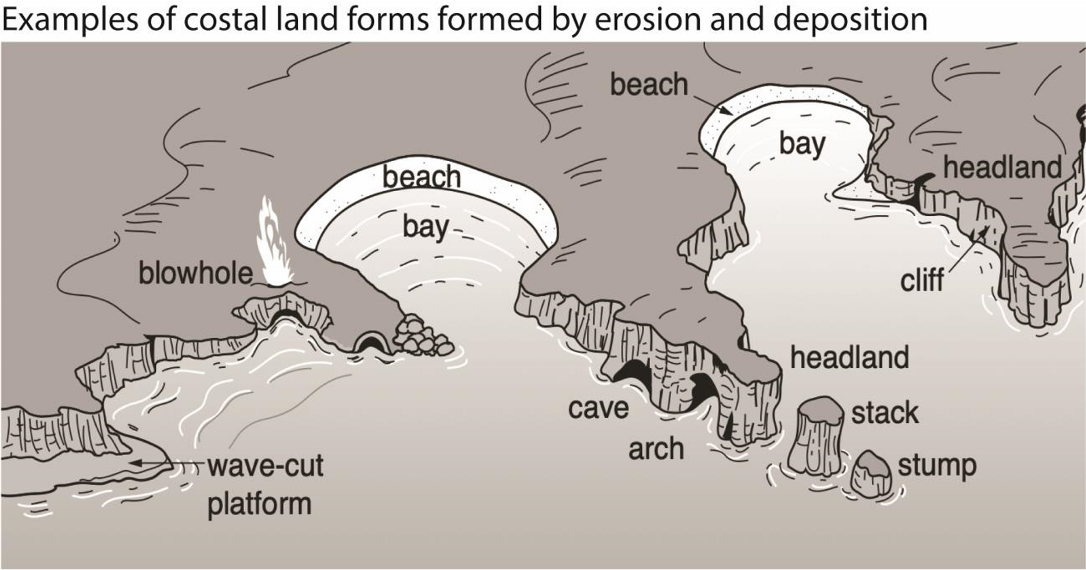
Characteristics of Coastal Landforms
- Cliffs and wave-cut platforms: Steep rock faces formed by erosion, with flat platforms at their base.
- Beaches: Depositional features of sand, gravel, or pebbles, dynamic and seasonal in shape.
- Spits and bars: Narrow ridges of sand extending into the sea due to longshore drift.
- Estuaries and deltas: Formed where rivers meet the sea, rich in biodiversity and sediment deposits.
- Coral reefs: Biological landforms built by coral organisms, protecting coasts from wave energy.
Evaluation of Significance
Landform | Significance in Coastal Landscape
Cliffs & platforms | Define rugged coastlines, attract tourism, but prone to erosion hazards
Beaches | Provide recreation, buffer against waves, but vulnerable to storms and sea-level rise
Spits & bars | Alter coastal hydrology, create lagoons, influence navigation
Estuaries & deltas | Support fisheries, agriculture, and biodiversity; highly sensitive to pollution
Coral reefs | Protect shorelines, sustain marine ecosystems, but threatened by climate change
Longshore processes—these are coastal processes driven by waves approaching the shore at an angle, which transport sediment along the coastline.

Depositional landforms formed due to constructive waves
- Beach
A Beach is a gently sloping strip of land along the coastline covered products of weathering and erosion such as sand, pebbles, rock and seashell fragments.
The different types of beaches include
    - Barrier beach is a narrow and elongated ridge of sand deposits approximately parallel to the shoreline separated from it by a lagoon. It is formed on gently sloping Coastlines by longshore drift waves. Materials are deposited under water as off shore sand bars appear above high tide, wave action gradually moves the deposited material to the mainland as barrier beaches.
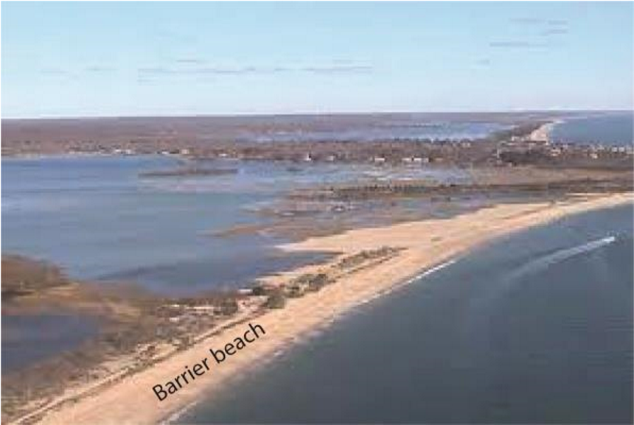
    - Beach Cusps. Series of small horn-shaped projections separated by shallow indentations that Point Sea wards. Formed by eddies of powerful swash that scours coarser materials in the depression.
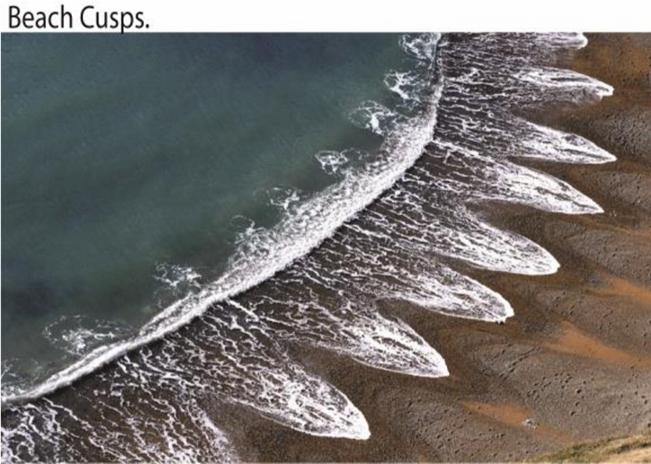

    - A Bayhead beach is a type of beach that is crescent shaped and has developed at the head or back of a bay between two headlands by constructive waves e.g. Lido beach at Entebbe
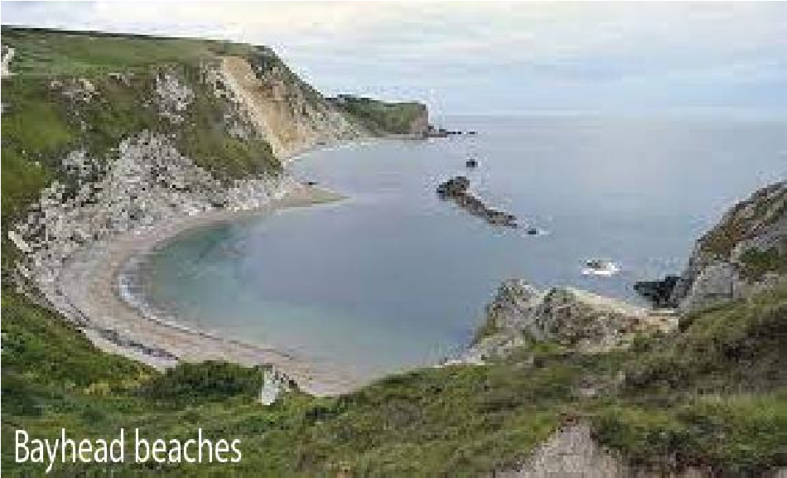

    - Beach rock is a friable to well-cemented sedimentary rock that consists of a variable mixture of gravel, sand and silt-sized sediment that is cemented with carbonate minerals and has formed along a shoreline e.g. found at Lutembe beach along L. Victoria
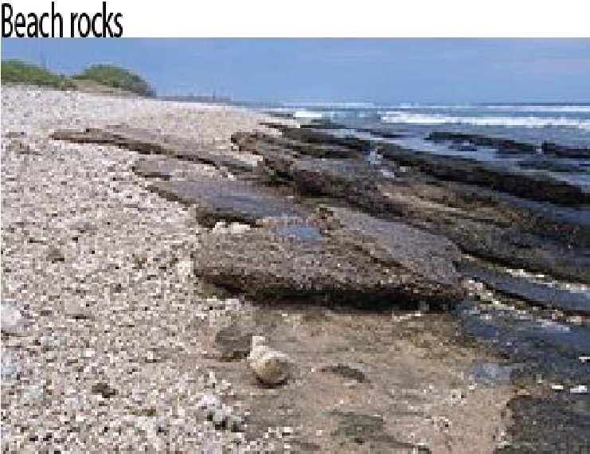

    - Beach Berms is ridge like features formed by larger material that accumulates at furthest limit of Swash action. Develop on beaches when Swash is stronger than back wash e.g. Lutembe Beach, Lido etc.
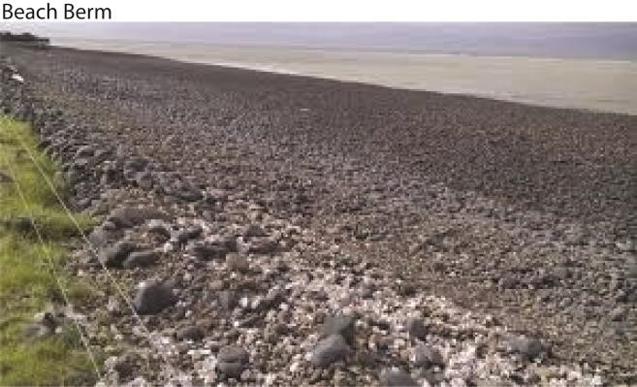

- Beach Bars
Beach Bars are ridges of sand, Mud, gravel and shingle deposited off shore parallel to the coast.

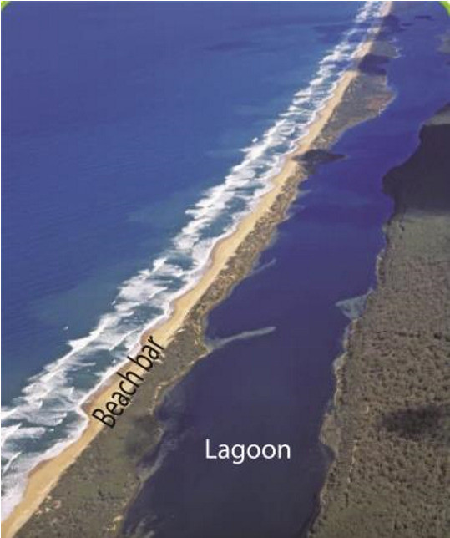
A lagoon is a lake formed by wave deposition between the sea and shoreline example Lake Nabugabo along the shores of Lake Victoria.

Types of Bars include:
    - Off Shore Bars are submerged or partly exposed ridge of sand or coarse sediment that is built by waves offshore from a beach separated from the coast by a lagoon. They are formed by waves breaking some distance offshore where the continental shelf is shallow leading to formation of a submarine bar that is slowly built upwards through continued deposition of material.
    - Fore shore Sand Bar is a bar formed by constant accumulation of sand causing offshore bars to rise above the water surface. ,
    - Bay Bar is a bar which extends across a bay forms when a spit continues to grow lengthwise from one headland towards another. Link the two headlands enclosing a lagoon e.g. at Nabugabo bay.
    - Barrier Island is a bar which gradually moves inland by wave attack and encloses the area of shallow water and have no connection to the mainland.

- Spit
A spit is a long narrow ridge of sand, shingle or pebbles in a linear form joined to the land at one end with the other end projecting into the sea or across the estuary.

It grows out from the coastline due to the effect of the long shore drift, often at a location where the line of the coast changes direction, usually at the mouth of an estuary or delta e.g. Kaiso spit and Tonya spit on L Albert.

Types of Spits include:
  - Hooked Spit is a long narrow ridge of sand, shingle or pebbles joined to the land on one side with hooked end projecting into the sea or estuary. Formed by waves moving obliquely to the shore tending to swing around the end of the spit or
waves approaching the shore from several directions force the open part of the spit to bend or curve. The deep water off the spit allows wave refraction to curve hence forming a hooked spit e.g. at Kibanga.
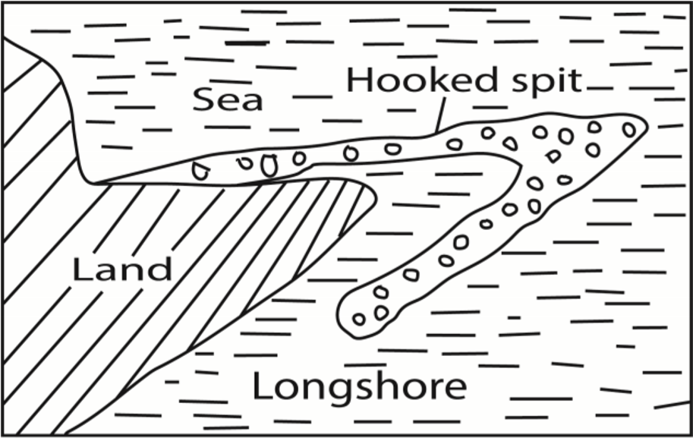
  - Cuspate Spit applies to two spit converging offshore. It is also a re-curving of a simple spit until it becomes attached to the shore at both ends.
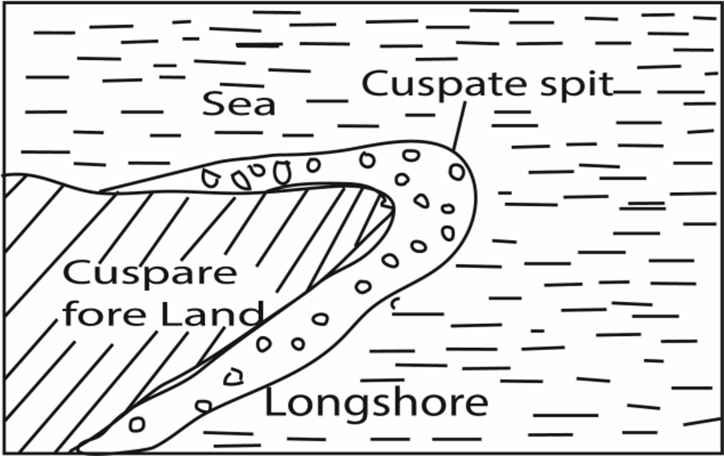
  - Cuspate foreland is a triangular shaped deposit of sand, shingle projecting sea wards formed by convergence to one apex of two separate curved spits broadly at right angles or by two sets of constructive waves, the enclosed water is filled with deposits then colonized by vegetation leading to a cuspate foreland, e.g at Tonya point.

  - Winged headlands: These are spits attached at both sides of the headland. They develop when spits develop at both sides of the headland. This occurs when waves / longshore drift reach the headland from opposite directions.
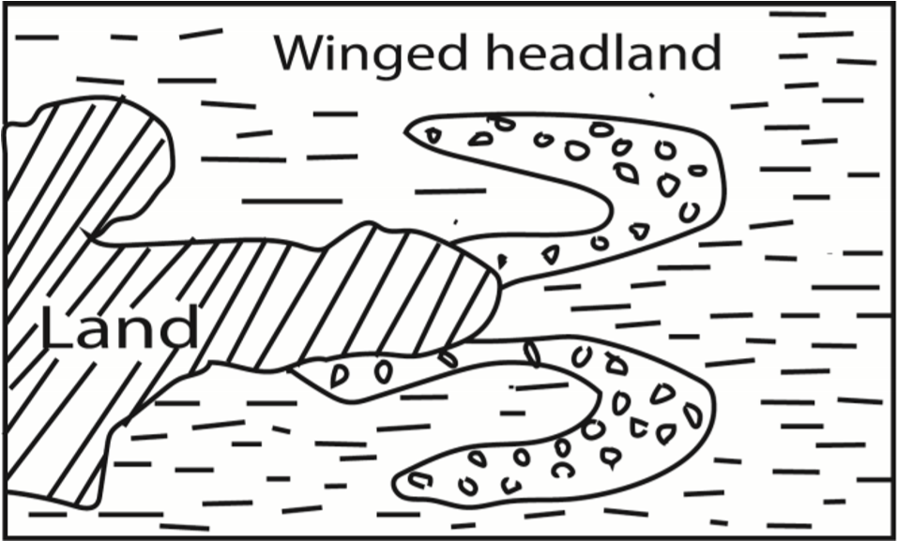
- Tombolo
A tombolo is a ridge/ bar of sand or shingle joining an island to the mainland or joining an island to digitalteachers.co.ug an island. When the longshore drift operates between an island and the mainland, sediments may gradually be laid down in that in that zone. Deposition may start on one end of the mainland linking the two up. E.g. BukakataLambu islands.
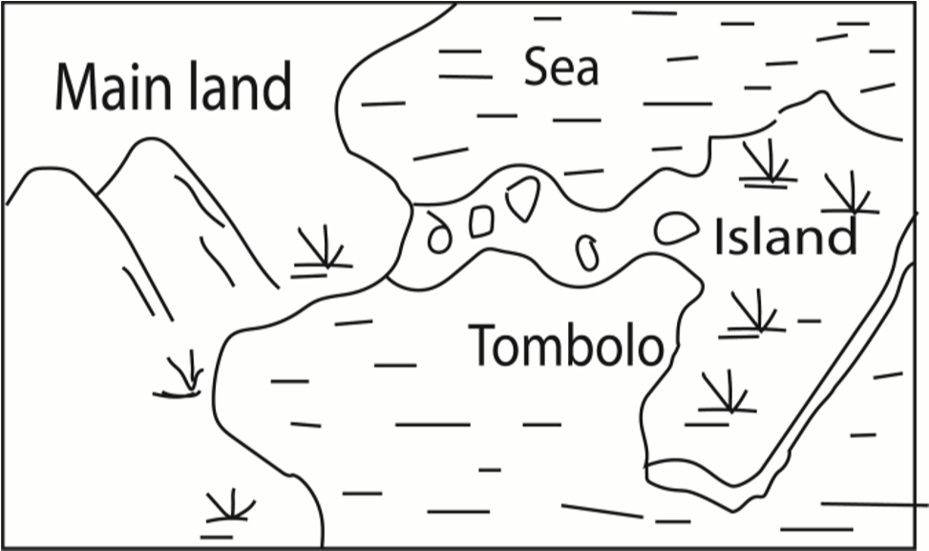
- Mudflats:
A mudflat is a platforms of mud, silt and other forms of alluvium along gentle is especially in bays & estuaries. They develop when rivers& waves deposit material along gentle coasts especially in bays and estuaries between high and low tides e.g. near Tanga, mouth of R. Rufigi.
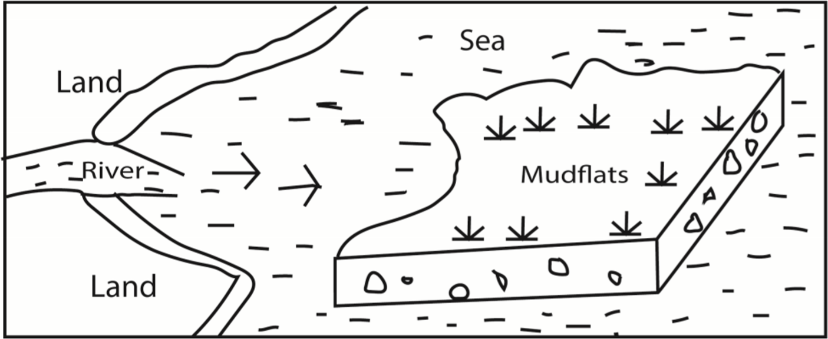

Other factors that influence depositional features in East Africa
- Wind direction which should be such that materials are carried and deposited on the coast.
- Availability of weathered and eroded materials that are transported by constructive waves and deposited at the coast to form various landforms e.g. beaches.
- Presence of a relative shallow continental shelf to form the base upon which material is deposited.
- Presence of organic deposits/corals due to deposition and accumulation of dead polyps.
- Nature of the coastline i.e. gently sloping allows deposition & accumulation of material leading to formation of depositional coastal features.

- Human activities e.g. dumping of industrial wastes at the coast/ shoreline, soil and rock boulders to construct piers etc.

(vii) River deposition at the mouth forming deltas

Processes through which destructive wave erode the coastline
Abrasion/corrosion occurs when waves use materials they are carrying such as pebbles, boulders, sand/shingles as gridding tool against the shoreline causing erosion

Hydraulic action occurs when waves send powerful S-waves that pound against the cliff face. When the water hit jointed cliff face, air is compresses within the cracks and suddenly expands which cause shock waves that break coastal rocks; for example at Kisenyi landing site

Corrosion/solution takes place mostly along limestone coastline where soluble rocks are dissolved leading to erosion features e.g. at Mombasa where there are coral limestone.

Attrition is an erosion process due to friction when material such as rocks and stones carried by waves hit and knock against each other and the coastline leading to erosional features.

Features formed by wave erosion/destructive waves
- Cliffs
Cliffs are vertical/steep rock faces found above high tide level. They are formed when waves cut a small notch on the coastland through the process of hydraulic action, abrasion or corrasion. Repeated wave action may cause to notch to develop into a steep face/cliff. e.g. at Fort Jesus, Botanical beach and Fort Gaza near Kilwa
Cliffs are formed when waves cut a small notch on the coast and through the process of hydraulic action, abrasion or corrosion.

- Wave-cut platforms
They are beach like coastal features slopping seaward below a cliff.

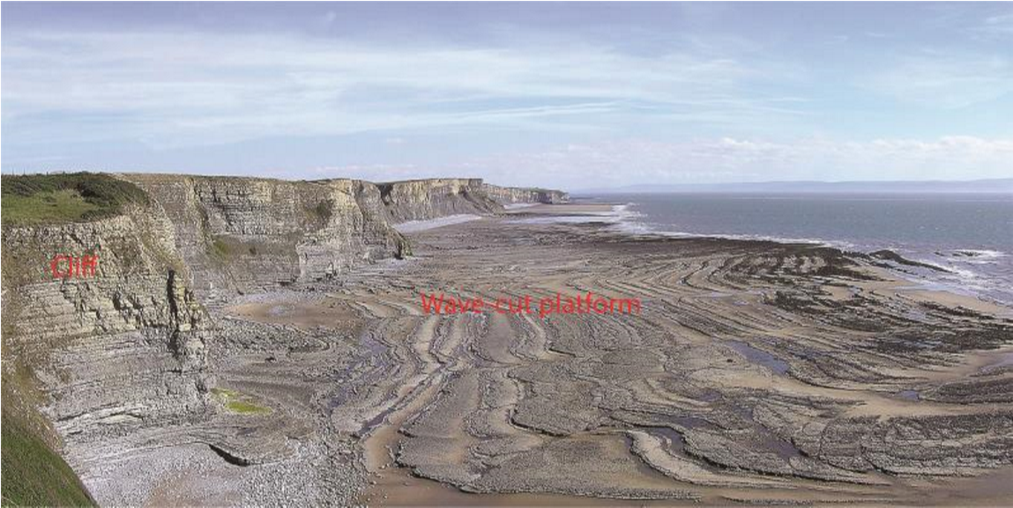

- Caves
  - cave is a cylindrical tunnel drilled through a cliff. It’s wide at entrance and narrow at the end. It is formed by hydraulic action, abrasion, corrasion and corrosion of waves. Examples of caves are caves are found at Lutembe beach, Tiwi beach and Kilifi in Kenya.
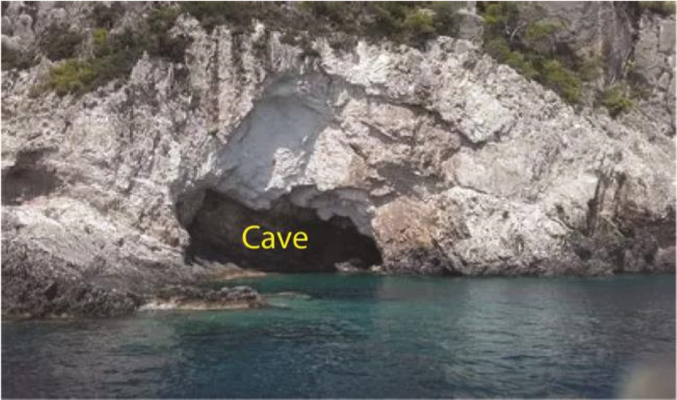
- Blow-hole/gloup
  - blowhole is hole in the ground that connects to an underground, partially submerged ocean cave. The cave and opening are shaped in such a way that when the ocean rises or waves crash into it, a jet of water and air is violently forced out through the hole.
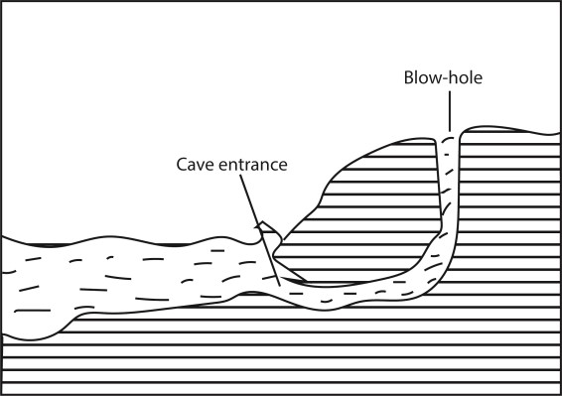

- Geo
  - geo is a narrow steep sided inlet along a cliff formed when entire roof of a cave collapses.

- Headlands
Are hard rock or pieces of land protruding into the sea because they have resisted erosion e.g. Entebbe peninsula, Mweya peninsula along L. Victoria.
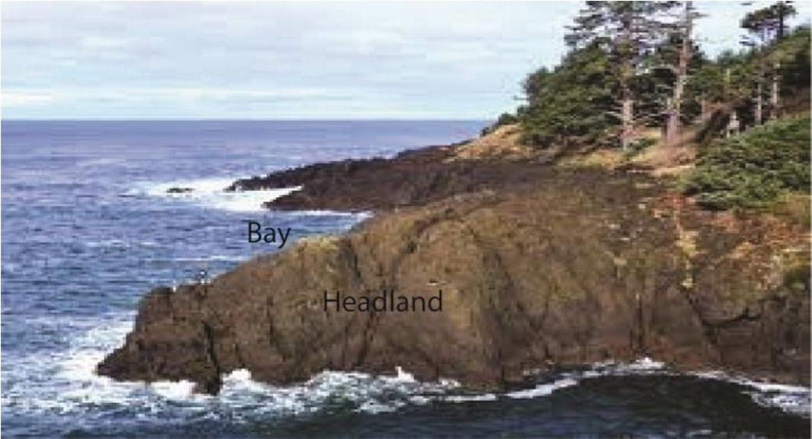
- Arches
An arch is a hole or inlet that drives through a headland. It is formed when wave action attacks headland either by hydraulic action or abrasion thereby drilling a tunnel below it and leaving a bridge like feature on top
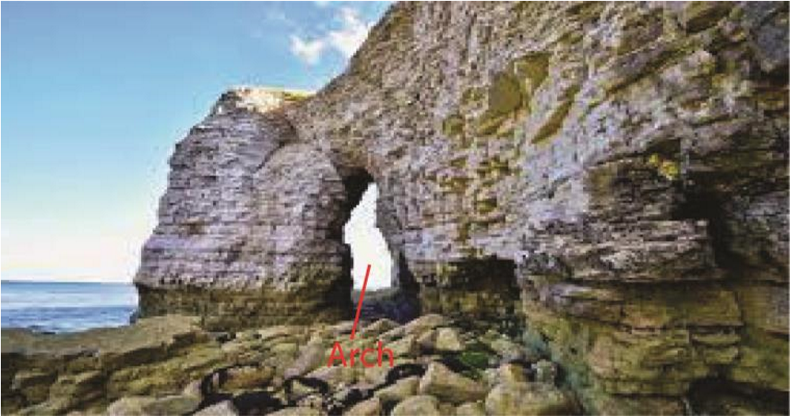

- Stacks
  - stack is an isolated rock feature completely detached from the mainland. It is formed when the roof of an arch on the headland collapses. Examples are rock pillar stacks near Entebbe airport, Kasenyi stack and stacks at Mombasa.
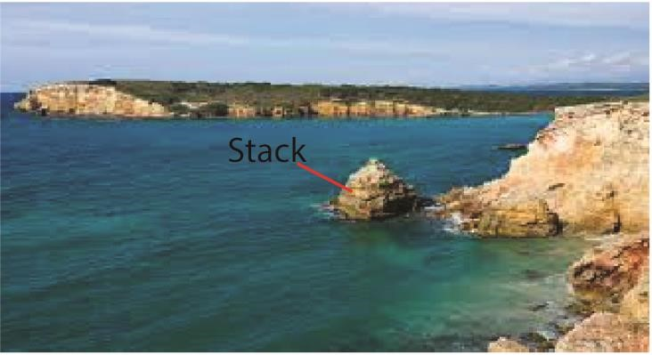

Importance of coastal features
Positive importance of coastal features
- Source of construction materials such as sand from beaches e.g. Kasenyi, Lutembe and Nabugabo along L. Victoria
- Bays and headland are used as landing sites e.g. Kasenyi and Majanji along L. Victoria (iii) The magnificent depositional and erosional features like cliff are tourist attraction sites.
- Mudflats along the East Africa coast (Mombasa) have mangrove forests and swamps where lumbering and crafts are done
- Bars and spits protect the coastland against floods and action of destructive waves (vi) Education and research.

Negative importance
- Waves bring poisonous snakes to the coast
- Strong waves cause floods
- Submerged sand bars and stumps are major causes of accidents
- Deposition of materials like snail lead to spread of diseases such as bilharzia.

Sea level changes
Sea level changes refer to the rise and fall of the sea level worldwide relative to the land or vertical movement of land relative to sea. The sea level is not static it fluctuates. A change in sea level is called eustatism. This can be positive when the sea level raises or negative where sea level falls/regresses.

Causes of sea level changes in East Africa
- Earth movements such as vulcanicity displace water and lead to rise in sea level while down warping lowers the sea floor lowering the sea level
- Freezing water on mountain top and Antarctic regions lowers the sea level while melting of ice snow on mountain top causes water to flow into the sea leading to a rise in sea level.
- Sedimentation causes a rise in sea level
- Heavy rainfall leads to a rise in sea level and evaporations causes a fall in sea level
- Global warming leads to general rise in room temperature and melting of ice on mountain tops causing a rise in sea level.
- Increase in temperature due to insolation or heat from vulcanicity causes expansion of water and rise in sea level while a fall in temperatures cause contraction of water leading to fall in sea level.
- Human activities like dumping of sewage, garbage, construction of artificial piers and Hotels on water have all led to a rise in the sea level. Over the world thousands of tones in form of hardcore stones and soils are deposited in the sea especially near: beaches to construct Hotels. In Uganda Speke Resort hotel at Munyonyo was partly constructed in Lake Victoria through a similar process.
- Rivers; the water deposited (poured) into the sea by rivers such as the Nile in Mediterranean, Tana into the Indian Ocean lead to a rise in the sea level.
- Reaction of hydrogen and oxygen; it's believed that hydrogen atoms from the sun often enter the earth's atmosphere and when they combine with oxygen in the ozone layer, rainfall is formed which enters into the sea to raise its level

Landforms resulting in a rise in sea level
It depends on whether they occur on highland or lowland (a) Highland coastal areas.
- Rias is a drowned river valley in highland coastal areas that remains open to the sea. They form in highland coastal areas where hills and river valleys meet the sea approximately at right angles. Examples are found at Mombasa, Dar-es-salaam, Mtwara etc
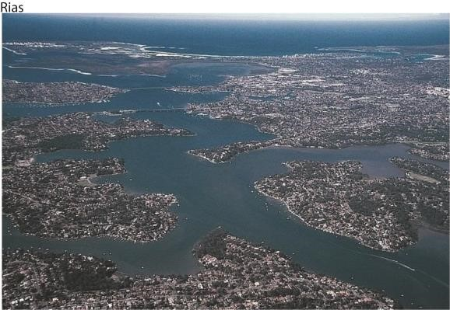

- Fjords. These are submerged U-shaped glacial troughs that reach far inland. They are deep elongated and have hanging valleys and truncated spurs. They form in highland coastal areas which are affected by glaciation where glaciers erode preglacial valleys through plucking and abrasion. The pre-glacial valleys are deepened, widened and lengthened, transforming formerly V-shaped valleys to a U-shaped cross profile. They are deeper downwards. When drowned due to a rise in sealevel fjords are formed. Examples include: at the coastal areas of Norway, British Colombia, Chile etc.

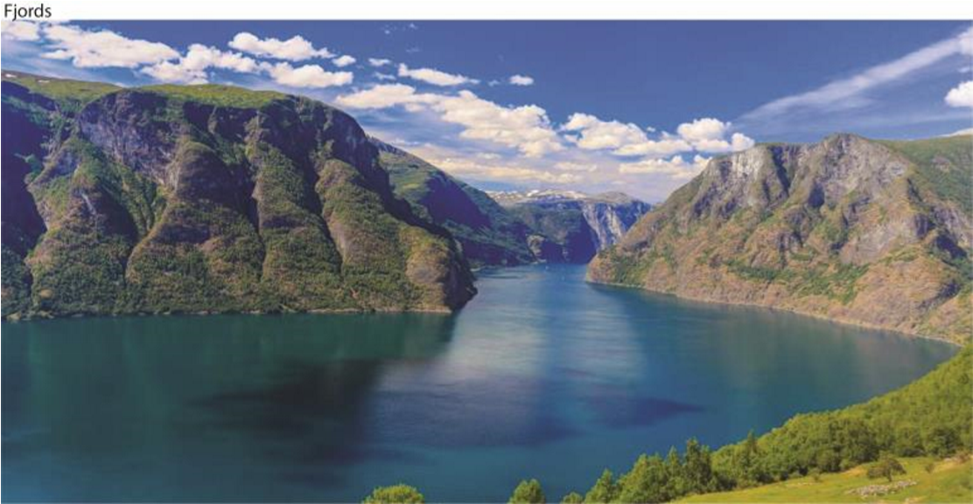

- Longitudinal Islands/Dalmatian coasts. These are straight and regular coasts, characterized by bays, sounds, where former valleys exist and peninsular and islands in areas of former hills. They form when highlands, ridges, river valleys run parallel to the coast. As the Sea - level rises, valleys are flooded and hills become chains of Islands running parallel to the coast. The resulting drowned hills are separated by parallel narrow inlets or valleys called sounds. Examples are found in Pemba, Zanzibar, Serbia, Crotia etc.
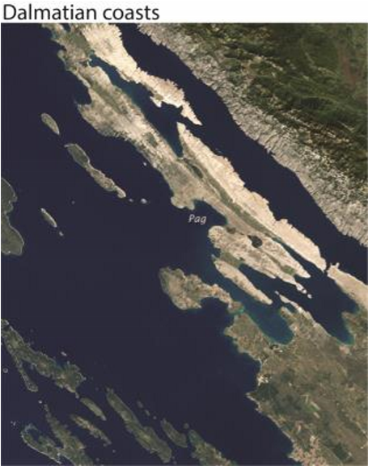
Sound is water separating the mainland from the longitudinal islands.
Peninsulas are pieces of land projecting into the sea (headlands) between bays. Valleys are drowned leaving highlands projecting sea-wards. Examples include, Entebbe peninsular, Mweya peninsular etc.

- Submerged landforms in lowland coasts include.
    - Estuaries are drowned/submerged river valleys in lowland areas for example at the mouth of rivers Wani and Rufigi along East African coast and R. Congo. Estuarine are formed like rias that form in highlands but estuarine form in low area.

    - Creeks are narrow inlets formed by submergence of small streams e.g. Kilifi, Makupa, Chacke etc.
    - Fjords are submerged large U-shaped glacial troughs that reach far inland in lowland glaciated areas. e.g.in South Eastern Sweden.
    - Mud flats. Are platform of fine silt and alluvium of rivers. Sediments are deposited in shallow water, either behind shingle, bars and spits or shelter apart of estuaries and bays. Examples of Mudflats can be found at Mombasa, Lamu, Tonya etc.

- Landforms resulting in a fall in sea level
These include raised beaches, raised cliffs, raised terraces, waterfalls and wave cut platforms.

Importance of features resulting from sea-level changes include
Positive importance
  - Rias provide natural harbor such as Mombasa.
  - Raised beaches are sources of sand example Lutembe beach
  - Raised beaches, terraces and cliffs promote tourism Negative importance

  - Fjords are not used for settlement or establishment of ports because they are associated with gorges and ragged terrain
  - Mudflats are associated with vectors like mosquitoes, malaria, bilharzia etc.

Influence of Coasts on Human Activities
Coasts are dynamic zones where land meets the sea, and they profoundly shape human activities. Their influence extends across economic, social, cultural, and environmental dimensions, making them vital to human settlement and development.
Settlement and Urban Development
- Population concentration: Many major cities (e.g., Lagos, New York, Tokyo) are located on coasts due to trade and access.
- Tourism hubs: Beaches and scenic coastlines attract tourists, fueling local economies.
- Cultural heritage: Coastal areas often host historic ports, fishing villages, and cultural landmarks.
Trade and Transportation
- Ports and harbors: Coasts provide natural harbors, enabling global trade and shipping.
- Fishing industry: Rich marine resources support livelihoods and food supply.
- Naval bases: Strategic coastal locations are used for defense and military operations.
Agriculture and Resource Use
- Fertile deltas: Coastal plains and river deltas support intensive farming (e.g., Nile Delta).
- Salt production: Coastal evaporation ponds provide salt for industry and consumption.
- Aquaculture: Fish farming and shellfish cultivation thrive in sheltered coastal waters.
Hazards and Challenges
- Coastal erosion: Threatens settlements, infrastructure, and farmland.
- Storm surges and flooding: Tropical cyclones and rising sea levels increase risks.
- Pollution and overuse: Industrial waste, oil spills, and overfishing degrade coastal ecosystems.

Revision questions
- To what extent has longshore drift influenced the development of depositional features in East Africa? (25marks)
(Candidates are expected to define the term longshore drift, talk about constructive waves, give the landforms that result from longshore drift then bring out other factors. Candidates are expected to make an evaluation and bring about other factors that influence depositional features in East Africa)
- (a) Account for the occurrence of sea level changes. (10marks)
(Candidates should define the term "sea-level changes'', identify and explain the causes of sea- level changes.)
  - Describe the land forms resulting from a rise in sea level. (15marks)
(Candidates should identify the land forms resulting from a rise in sea-level, describe their formation with illustrations. The landforms that form in highland and those that form in lowland coast area)
- Account for the formation of wave erosional coastal landforms in East Africa.
- (a) Examine the formation of wave depositional features along East Africa coast.
  - Assess the importance of wave depositional and erosional features in East Africa.

